Youtube- Kunal Kushwaha

Intro to programming and java architecture basics

Kunal’s notes are also in this link- https://github.com/kunal-kushwaha/DSA-Bootcamp-Java/tree/main/lectures
And I have also saved what I need in this folder

Here I am only writing important points:

- Static languages- Type checking at compile time
int a = 10;
a = “xyz”; // Error

- Dynamic languages- type checking at run time
a = 10
a = “xyz”
This will not be an error

- Stack memory, heap memory

a pointing to its value in the heap memory
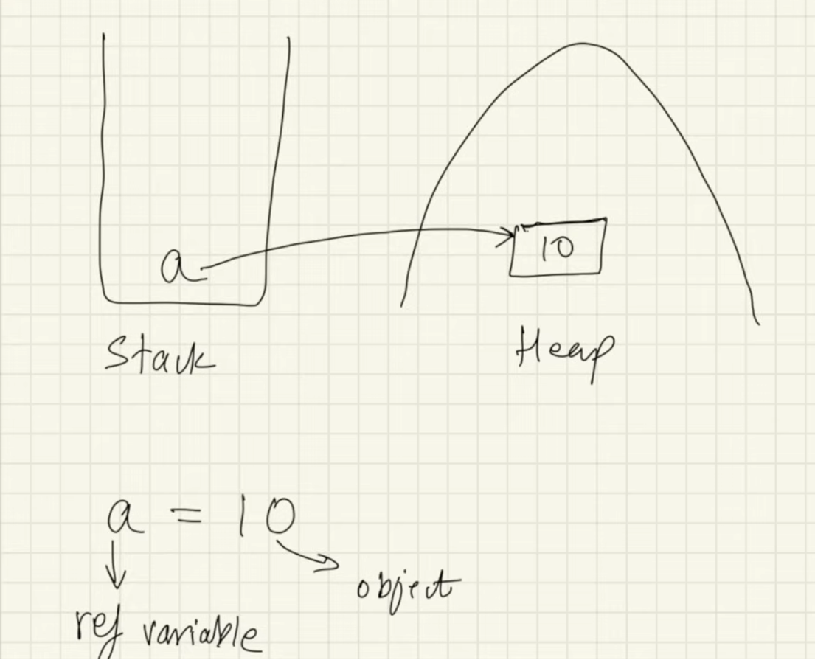

10 is the object and variable a is pointing to it
More than one reference variables can point to the same object

- When garbage collection happens, object with no reference variable will be removed from the memory.

a = 10;
a = 37;
Now, 10 will be removed from the memory.

// Both reference variables pointing to same object. Change in the object was reflected in both reference variables.
int[] array = {1, 3, 5};
int[] array_copy = array;
array[0] = 10;
System.out.println(array_copy[0]); //10

- Flowcharts

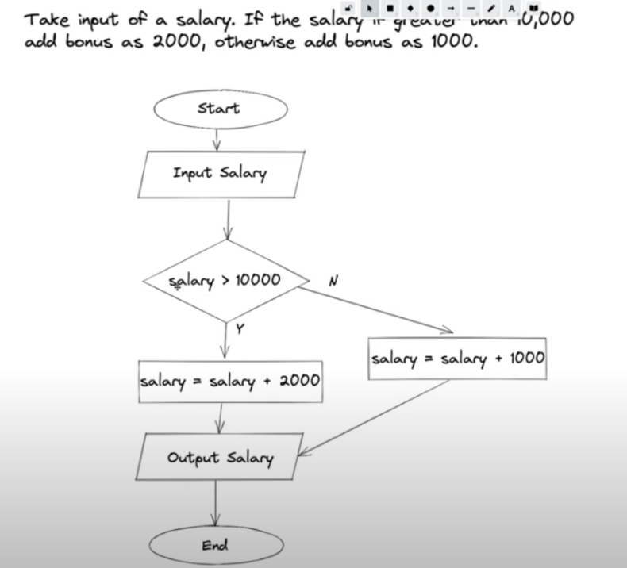
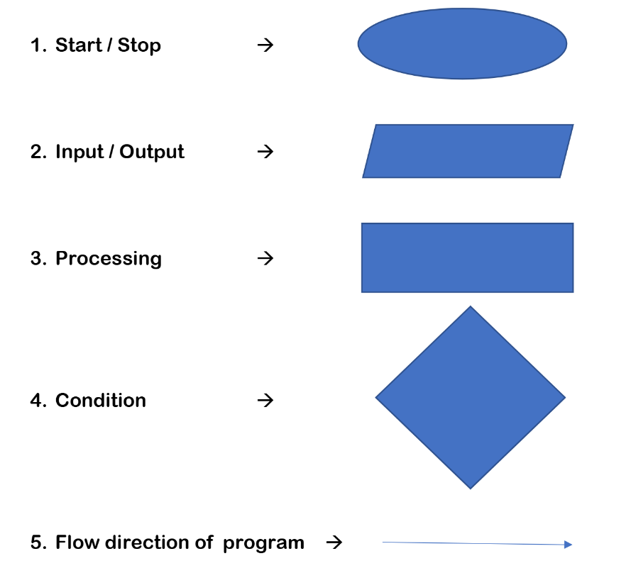

Pseudocode:

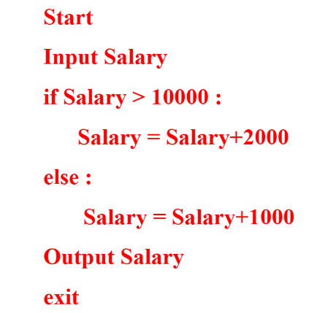

- For prime number checking, check only till the square root of the number in the program.
Because afterwards there will be repetition.
For example- if you check 4 X 9 = 36
Then you don’t need to check 9 X 4 = 36

- We need JVM to run the byte code- .class file
When JVM will run this file, it will be understood by your machine that means it will be converted to machine code.

Bytecode- independent of underlying OS or hardware architecture
JVM is platform dependent

We download JDK from the internet.

javac compiler

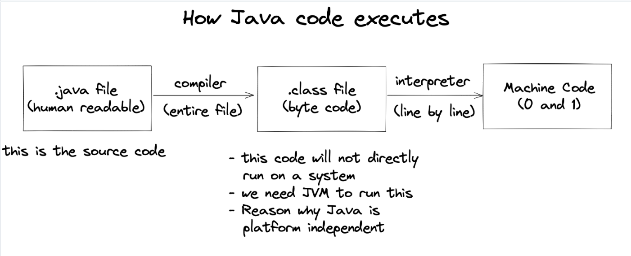

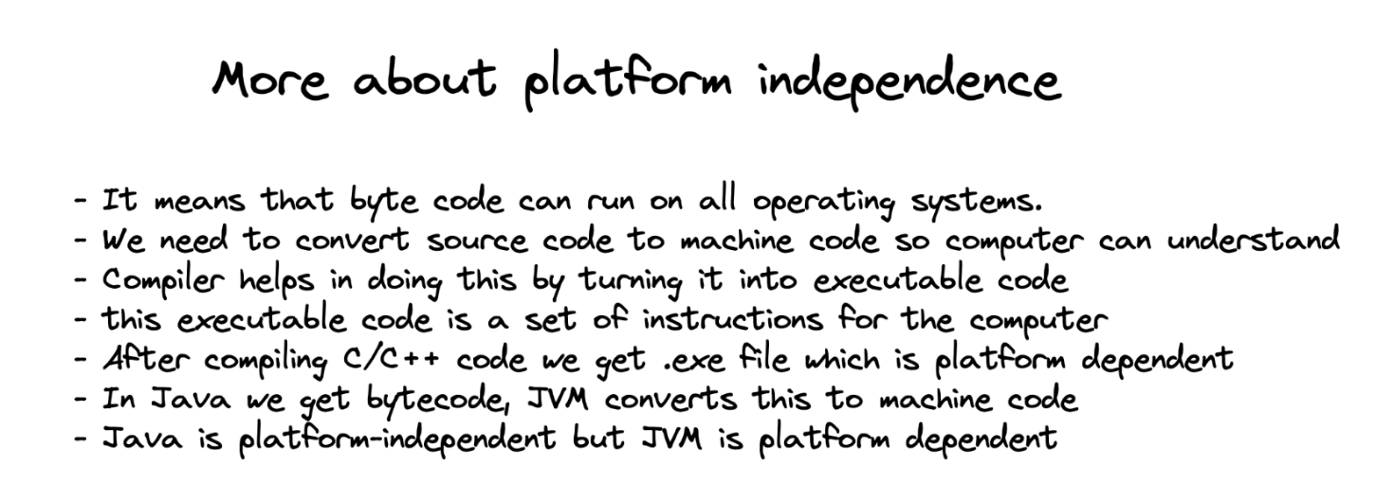

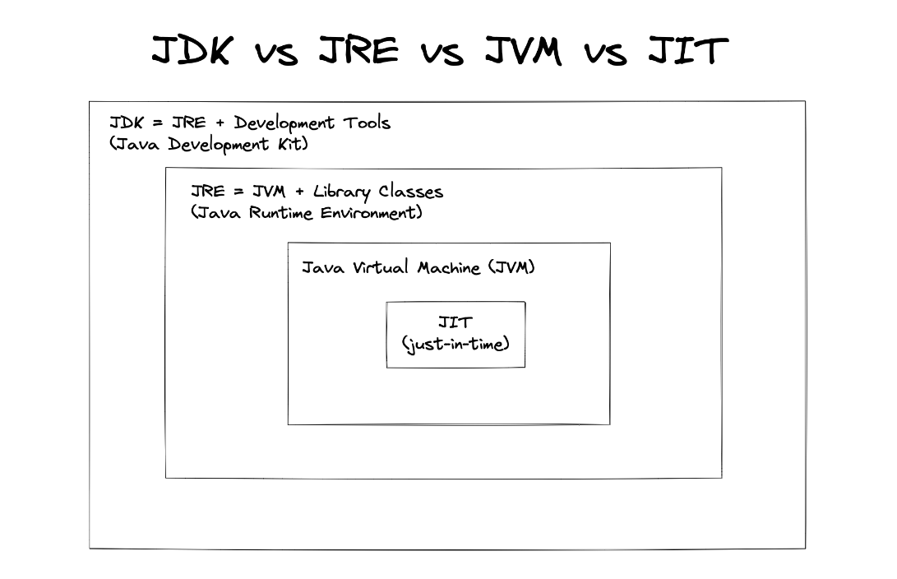

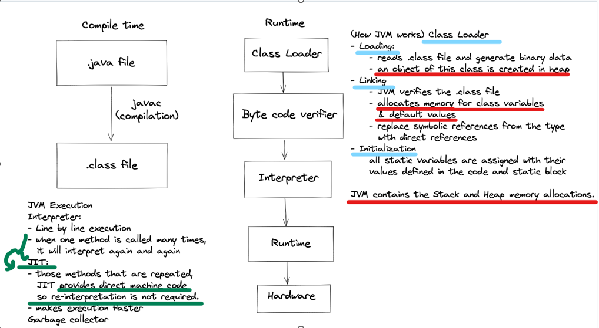

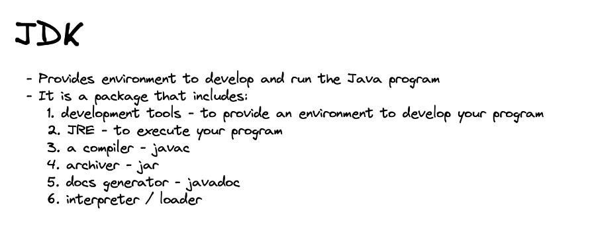

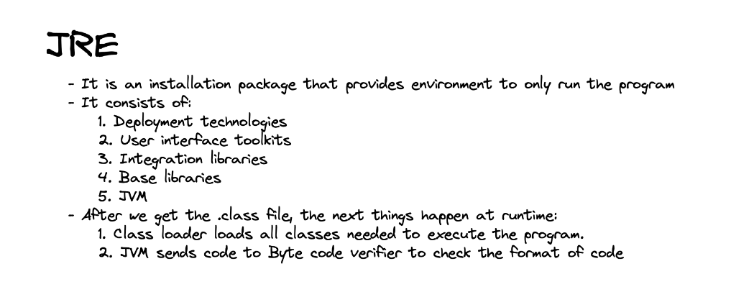

JDK – has compiler
JRE- has the things to support JVM

Just-In Time Compiler- makes execution faster by directly providing machine code for the repetitively used code.
______________________________

Reference from this video- https://www.youtube.com/watch?v=J_vAwYpRbhs&pp=ygUMY2xhc3MgbG9hZGVy0gcJCbIJAYcqIYzv

The java class loader is used to load .class files into the JVM at run time.

This video also explains types of class loaders.
___________________________

- Write Source Code: You write your Java code in a human-readable language and save it as a .java file. This is your source code.
- Compile to Byte Code: The Java compiler (javac) takes your entire .java file and converts it into an intermediate language called "byte code". This byte code is saved in a .class file.
- Load Class Files: When you run the program, the Java Virtual Machine (JVM) starts. The JVM's Class Loader reads and loads the necessary .class files (containing the byte code) into memory.
- Link Loaded Classes: After loading, the JVM performs "linking," which involves verifying the byte code for correctness, preparing memory for variables, and resolving references to other classes.
- Execute Byte Code: The JVM then executes the byte code. It uses an interpreter to translate the byte code line by line into machine code, and for frequently used parts, a Just-In-Time (JIT) compiler converts byte code directly into machine code for faster execution.
- Run on Hardware: The resulting machine code is then executed by your computer's hardware.

Class loader- in JRE
Byte code verifier- in JVM

